UNITED STATES
SECURITIES AND EXCHANGE COMMISSION
WASHINGTON, D.C. 20549
___________________________________
SCHEDULE 14A
Proxy Statement Pursuant to Section 14(a) of
the Securities Exchange Act of 1934
___________________________________
Filed by the Registrant ☒
Filed by a Party other than the Registrant ☐
Check the appropriate box:
☐ |  |  | Preliminary Proxy Statement
☐ |  |  | Confidential, for Use of the Commission Only (as permitted by Rule 14a-6(e)(2))
☐ |  |  | Definitive Proxy Statement
☒ |  |  | Definitive Additional Materials
☐ |  |  | Soliciting Material under §240.14a-12

INTUITIVE MACHINES, INC.
_________________________________________________________________________________________________
(Name of Registrant as Specified in Its Charter)

_________________________________________________________________________________________________
(Name of Person(s) Filing Proxy Statement, if other than the Registrant)

Payment of Filing Fee (Check the appropriate box):
☒ |  |  |  |  |  | No fee required.
☐ |  |  |  |  |  | Fee paid previously with preliminary materials.
☐ |  |  |  |  |  | Fee computed on table in exhibit required by Item 25(b) per Exchange Act Rules 14a-6(i)(1) and 0-11.

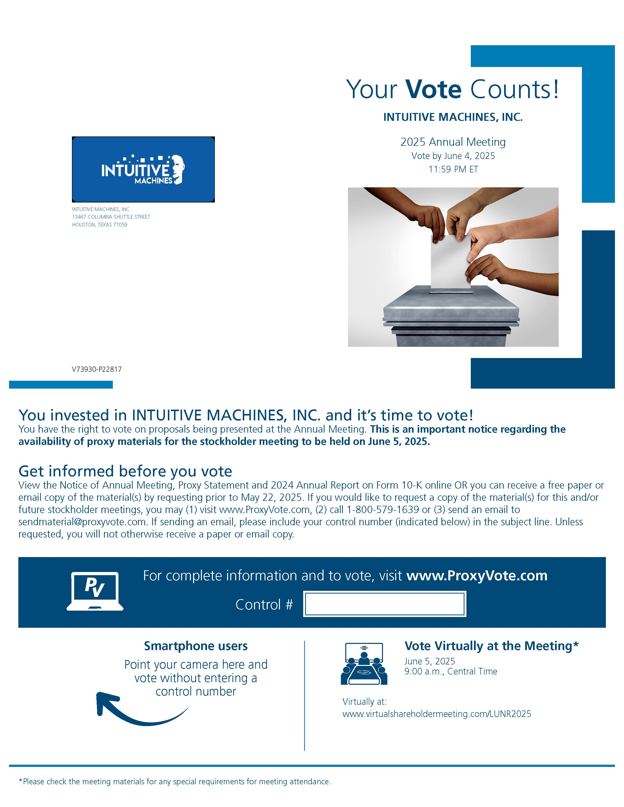

INTUITIVE MACHINES, INC | 2025 PROXY STATEMENT |  |  | 2

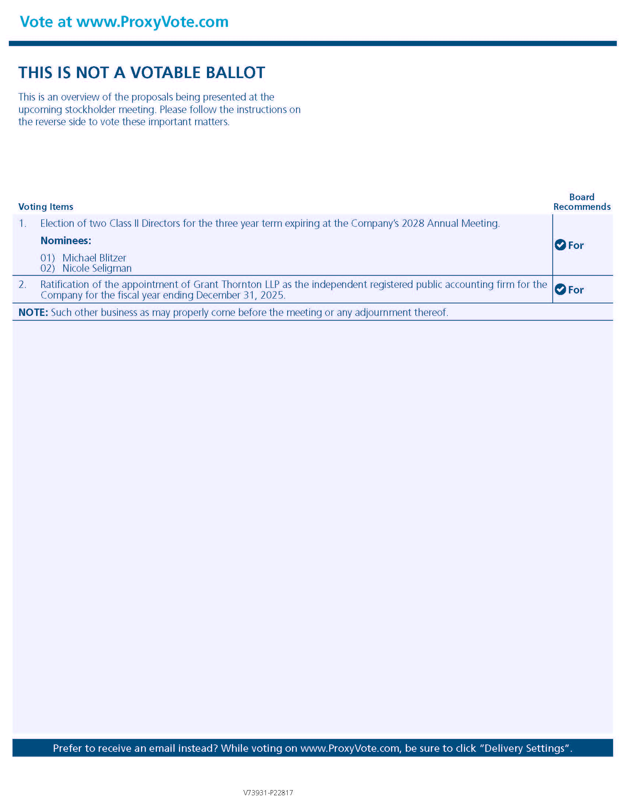
INTUITIVE MACHINES, INC | 2025 PROXY STATEMENT |  |  | 3

